**Assignment:**

1. Import `travel-sample` bucket

* Go to settings->sample buckets

Then simply just use travel-sample and load sample data.

1. Write a query to get the sum of all distances where type=”route” for each airline id.



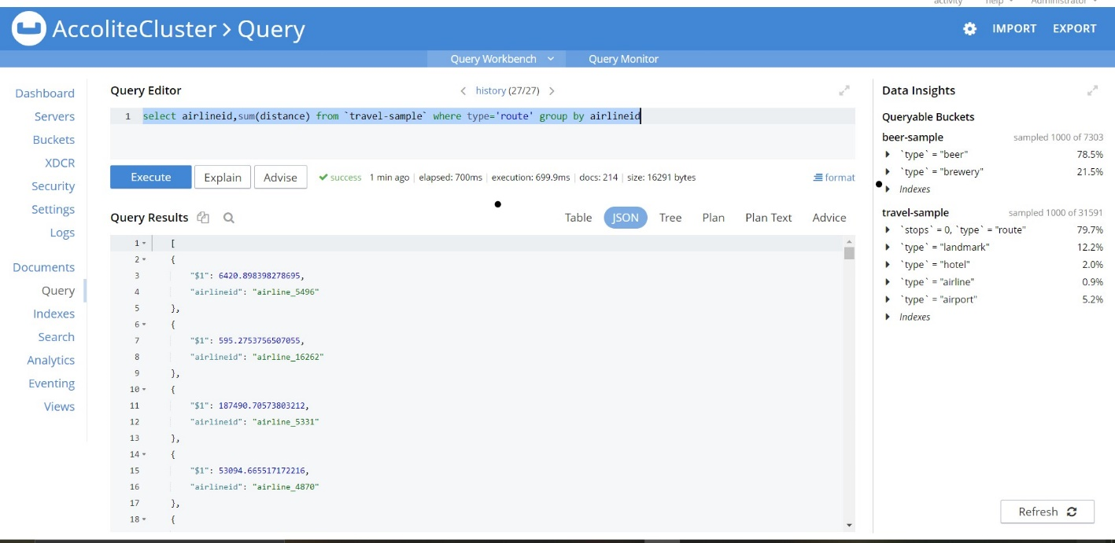

1. Write queries to join(LEFT,RIGHT,INNER) type=”route”&“airline” and fetch the data whose sourceairport=”SFO”



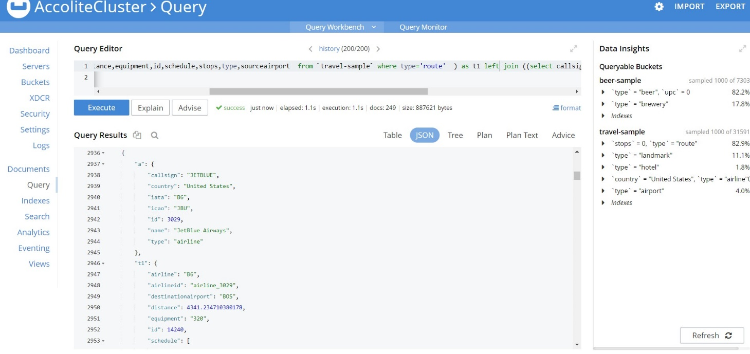



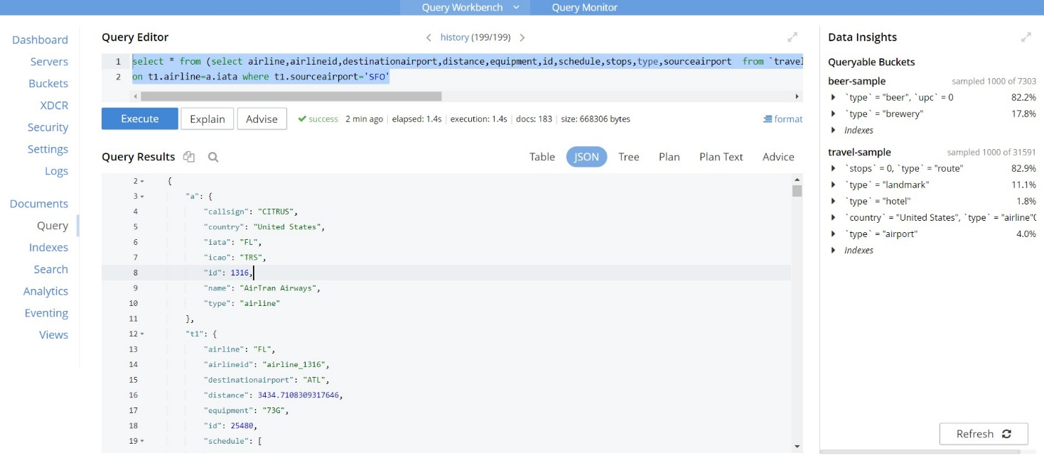



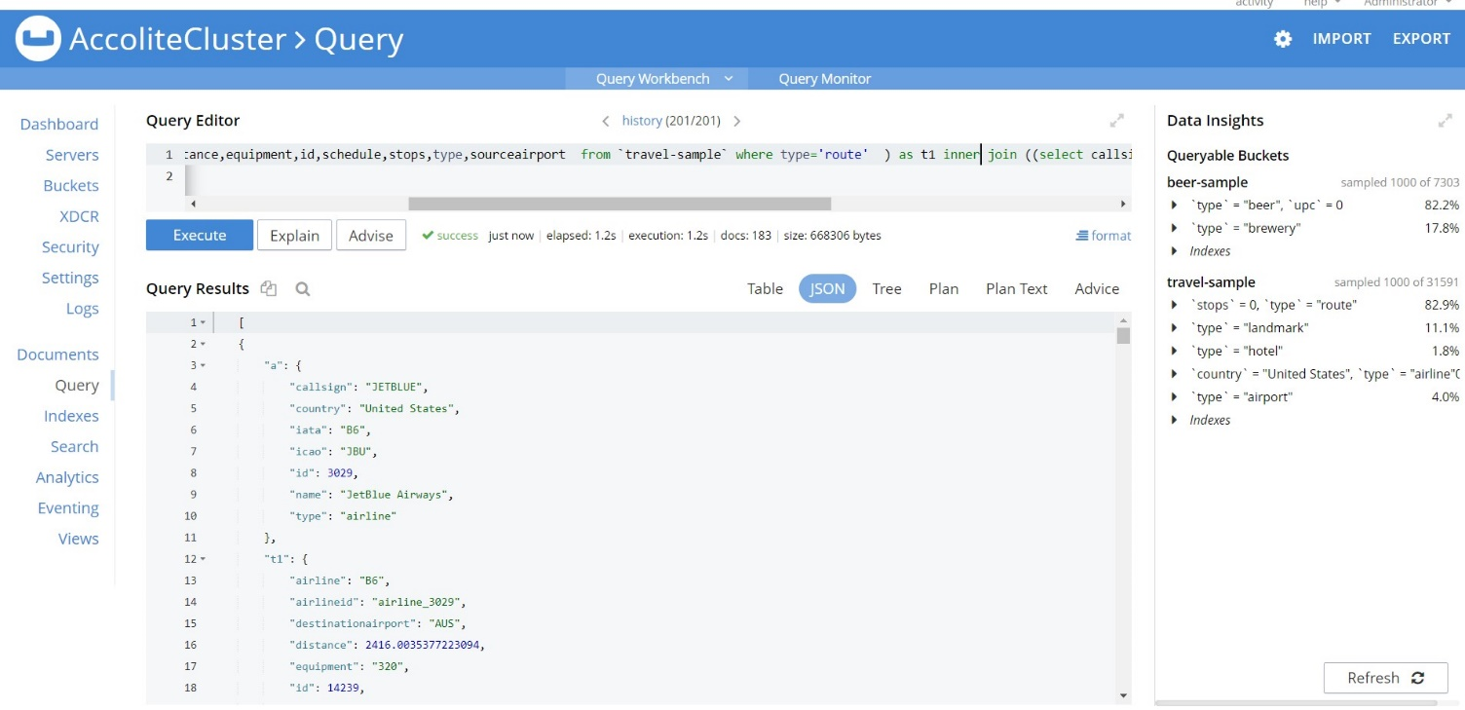

1. Write a mapreduce to get the number of all documents based on entities(type).

* Map function



Reduce function



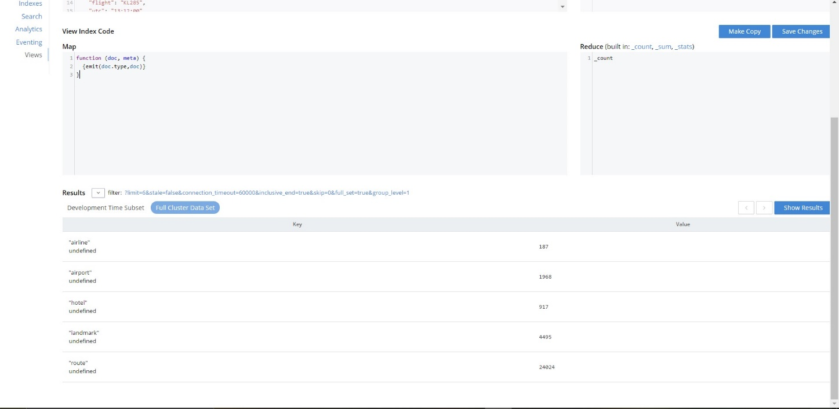

1. Refer CLI interface & try to export the travel sample data. Below are the steps:
   1. Go to Couchbase Bin folder - C:\Program Files\Couchbase\Server\bin
   2. Open Command Prompt from the bin folder

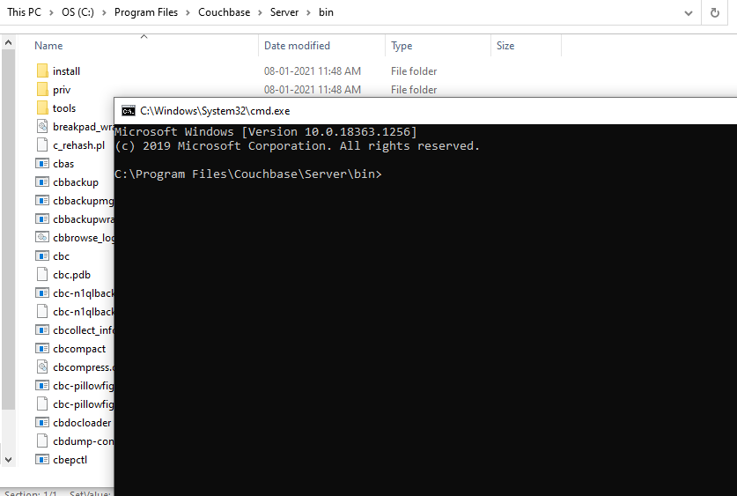

* 1. Run the below command to export the data from travel-sample bucket:

cbexport json -c couchbase://127.0.0.1 -u <USER NAME> -p <password> -b travel-sample -o C:/travelSample.json -f lines -t 4

1. Create a new Bucket “NewBucket” & import the data to it:

cbimport json -c couchbase://127.0.0.1 -u <User Name> -p <password> -b NewBucket -f lines -d file://C:/travelSample.json -t 4 -g %id%

1. Once the data is imported, please attach the screenshot.

Note:

-u --> UserId which you’ve created

-p --> password

-b --> bucket name



//exporting from travel-sample bucket

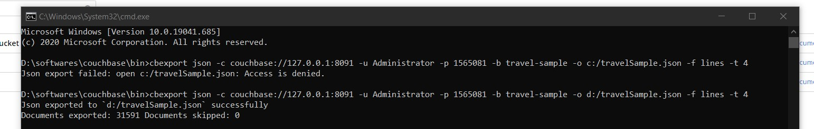

//after creating a new bucket and now importing

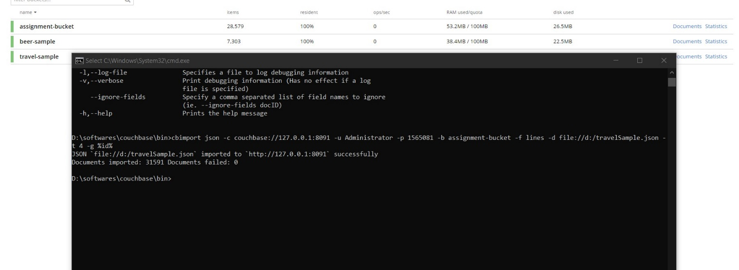

//after importing

